Lab No. 03

STL Sequential Containers: Array & Vector
Task 1 [10]
Declare an STL array of size 500 and populate is with random integers. Write a function even_odd_average to find the average of even and odd numbers separately.
Code:

#include <iostream>
#include<array>
using namespace std;
void even_odd_average(array<int, 500>& num) {
int even_sum = 0;
int odd_sum = 0;
for (int i = 0; i < 500; i++) {
if (i % 2 == 0) {
even_sum += num[i];
}
else {
odd_sum += num[i];
}
}
cout << "Even Sum is : " << even_sum << endl;
cout << "Odd Sum is : " << odd_sum << endl;
}
int main() {
array<int, 500> num;
for (int i = 0; i < 500; i++) {
num[i] = i;
}
even_odd_average(num);
return 0;
}
Output:
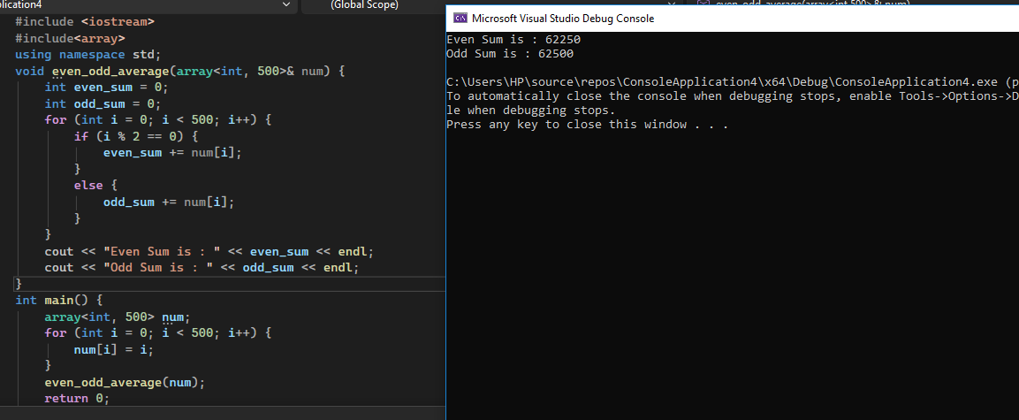

Task 2 [5]
Write the definition of the function template reverse_vector to reverse the elements of a vector object.

Code:

#include <iostream>
#include <vector>
using namespace std;
template <class elemType>
void reverse_vector(vector <elemType>& list) {
int n = list.size();
for (int i = 0; i < n / 2; i++) {
elemType temp = list[i];
list[i] = list[n - i - 1];
list[n - i - 1] = temp;
}
}
int main() {
vector<int> testVec = { 4, 8, 2, 5 };
cout << "Original: ";
for (int i = 0; i < testVec.size(); i++)
cout << testVec[i] << " ";
reverse_vector(testVec);
cout << "\nReversed: ";
for (int i = 0; i < testVec.size(); i++)
cout << testVec[i] << " ";
return 0;
}
Output:

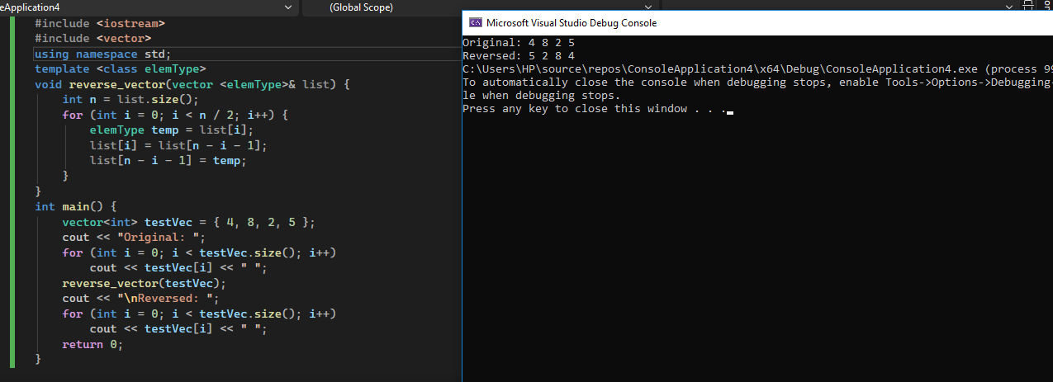

Task 3 [4+4+2=10]
Create an integer type vector of size 500. Populate this vector using filler function. Use this vector for following subtasks.
- Write a function which returns the maximum value and the associated index of the passed vector. Its prototype would like as follows;
int vec_max(vector<int> & vec, int & pos);

- Write a function which adds index position of the passed vector in the existing values of this passed vector.
void vec_seq_num(vector<int> & vec);
Test these functions by making call to them in a main() function.
Code:

#include <iostream>
#include <vector>
using namespace std;
int vec_max(vector<int>& vec, int& pos) {
int max_value = vec[0];
pos = 0;
for (int i = 1; i < (int)vec.size(); i++) {
if (vec[i] > max_value) {
max_value = vec[i];
pos = i;
}
}
return max_value;
}
void vec_seq_num(vector<int>& vec) {
for (int i = 0; i < (int)vec.size(); i++) {
vec[i] += i;
}
}
int main() {
vector<int> my_vector(500);
for (int i = 0; i < (int)my_vector.size(); i++) {
my_vector[i] = i * 2;
}
int pos;
int max_value = vec_max(my_vector, pos);
cout << "Maximum value: " << max_value << " at index: " << pos << endl;
vec_seq_num(my_vector);
cout << "Vector after adding index positions:" << endl;
for (int i = 0; i < (int)my_vector.size(); ++i) {
cout << my_vector[i] << " " << endl;
}
return 0;
}

Output:

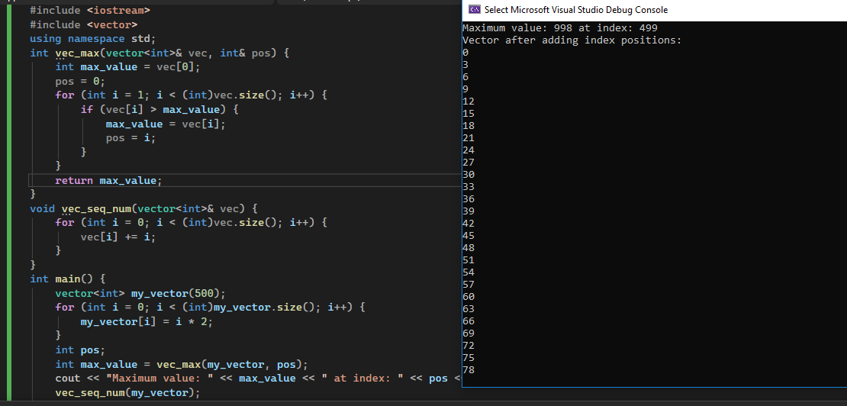

Task 4 [5+5+5=15]
Create a vector of integer type of arbitrary size and populate it using following filler function.
Part A
Create a function split_vector() which takes above vector as input and split this vector into two vectors, i.e.v1 & v2, in such a way that v1 contains all even numbers & v2 contains all odd numbers and return both vectors back to caller function.
Part B
Write another function which takes a vector and remove all duplicate numbers.
Part C
Now calculate sum of elements of each vector (i.e. v1 & v2), after removing all duplicate elements from vectors, using function sum which you have created in Lab 1.

Code:

#include <iostream>
#include <vector>
using namespace std;
void split_vector(const vector<int>& input, vector<int>& v1, vector<int>& v2) {
for (int num : input) {
if (num % 2 == 0) {
v1.push_back(num);
} else {
v2.push_back(num);
}
}
}
void remove_duplicates(vector<int>& vec) {
vector<int> unique_vec;
for (int i = 0; i < vec.size(); i++) {
int currentNum = vec[i];
int duplicateFound = 0;
for (int j = 0; j < unique_vec.size(); j++) {
if (unique_vec[j] == currentNum) {
duplicateFound = 1;
}
}
if (duplicateFound == 0) {
unique_vec.push_back(currentNum);
}
}
vec = unique_vec;
}
int sum(const vector<int>& vec) {
int total = 0;
for (int num : vec) {
total += num;
}
return total;
}
int main() {
vector<int> input = {1, 2, 3, 4, 5, 6, 7, 8, 9, 10, 2, 3};
vector<int> v1, v2;
split_vector(input, v1, v2);
remove_duplicates(v1);
remove_duplicates(v2);
int sum_v1 = sum(v1);
int sum_v2 = sum(v2);
cout << "Sum of even numbers (v1): " << sum_v1 << endl;
cout << "Sum of odd numbers (v2): " << sum_v2 << endl;
return 0;
}
Output:
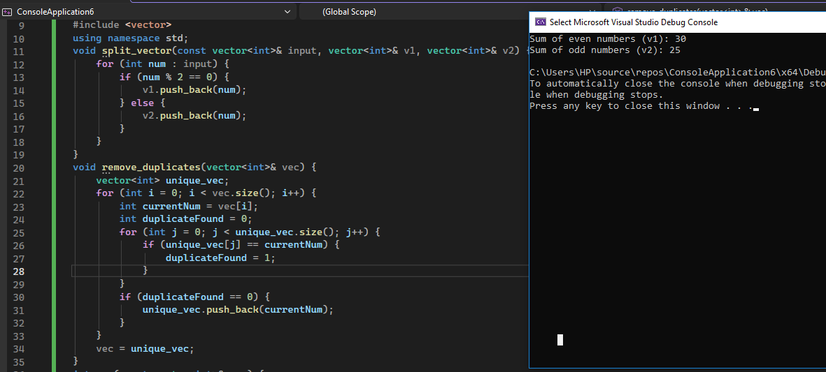
Task 5 [2+3+3+2=10]
Say we are writing the next version of a nifty new mail reading program and want to use a Vector (interface in reader appendix) to store all the data. The following structure is used to hold the data of an email message:
struct eMailMsg {
string to; // i.e. "professor@abasyn.edu.pk"
string from; // i.e. "student@@abasyn.edu.pk "
string message; // body of message
string subject; // i.e. "CS210 Rocks!"
int date; // date email was sent
int time; // time email was sent
};
a) How would you declare a Vector that stores eMailMsgs?
b) Write a function RemoveSpam that takes a vector containing elements of type eMailMsg and removes all elements whose subject begins with the string "SPAM".
c) How could you modify the field of the eMailMsg structure so that it can hold the email addresses of an arbitrary number of recipients of an email? With the modification in place, given an eMailMsg email, how would you access the last address listed in the field?

Code:

#include <iostream>
#include <vector>
#include <string>
using namespace std;
struct eMailMsg {
string to;
string from;
string message;
string subject;
int date;
int time;
};
void RemoveSpam(vector<eMailMsg>& emails) {
cout << "\nChecking for spam emails..." << endl;
for (int i = emails.size() - 1; i >= 0; i--) {
string sub = emails[i].subject;
if (sub.length() >= 4 &&
sub[0] == 'S' &&
sub[1] == 'P' &&
sub[2] == 'A' &&
sub[3] == 'M') {
cout << "Removing spam: " << sub << endl;
emails.erase(emails.begin() + i);
}
}
}
void printEmail(const eMailMsg& email) {
cout << "To: " << email.to<<endl;
cout << "From: " << email.from << endl;
cout << "Subject: " << email.subject << endl;
cout << "Message: " << email.message << endl;
cout << "Date: " << email.date << endl;
cout << "Time: " << email.time << endl;
}
int main() {
vector<eMailMsg> emails;
eMailMsg email1;
email1.to = "ali@abasyn.edu.pk";
email1.from = "teacher@abasyn.edu.pk";
email1.subject = "CS210 Assignment";
email1.message = "Please submit your assignment";
email1.date = 20240315;
email1.time = 1430;
eMailMsg email2;
email2.to = "student@abasyn.edu.pk";
email2.from = "spammer@unknown.com";
email2.subject = "SPAM: Win a Prize!";
email2.message = "Click here to win...";
email2.date = 20240315;
email2.time = 1500;
eMailMsg email3;
email3.to = "all@abasyn.edu.pk";
email3.from = "advertising@company.com";
email3.subject = "SPAM: Buy Now!";
email3.message = "Limited time offer...";
email3.date = 20240315;
email3.time = 1600;
eMailMsg email4;
email4.to = "students@abasyn.edu.pk";
email4.from = "dean@abasyn.edu.pk";
email4.subject = "Holiday Announcement";
email4.message = "University will remain closed...";
email4.date = 20240315;
email4.time = 1700;
emails.push_back(email1);
emails.push_back(email2);
emails.push_back(email3);
emails.push_back(email4);
cout << "All emails before removing spam:\n";
for (int i = 0; i < emails.size(); i++) {
printEmail(emails[i]);
}
RemoveSpam(emails);
cout << "\nEmails after removing spam:\n";
for (int i = 0; i < emails.size(); i++) {
printEmail(emails[i]);
}

return 0;
}
Output:

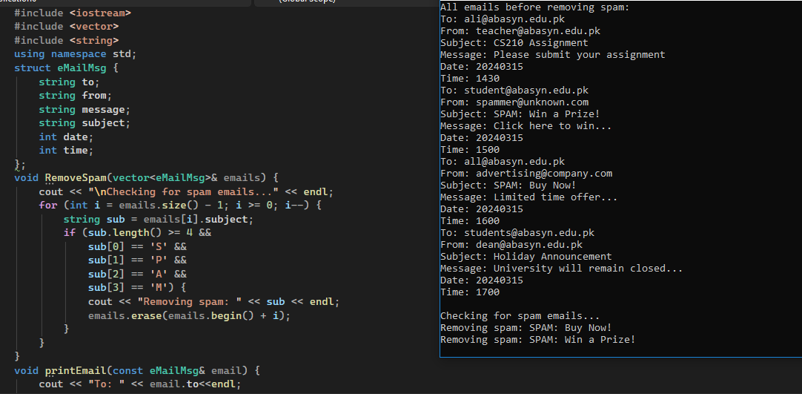
Task 6 [10]
Write a function CountLetters that takes a filename and prints the number of times each letter of the alphabet appears in that file. Because there are 26 numbers to be printed, CountLetters needs to create a Vector. For example, if the file is: Abcd K.. ijk;; cab-Bage fad
CountLetters should print the following:
a: 4
b: 3
c: 2
d: 2
...
z: 0
When you really print this out, it should be 26 elements long, but we couldn't easily display that on the page. Note that there may be upper case letters, lower case letters, and non-letter characters in the file. All letters should be counted regardless of case (so “Aa” is two a’s), and non-alphabetic characters should be ignored. You should use the following prototype.
void CountLetters(string filename);

Code:

#include <iostream>
#include <vector>
#include <fstream>
using namespace std;
void createFile() {
ofstream out("test.txt");
out << "Abcd K.. ijk;; cab-Bage fad" << endl;
out << "Hello World 123 !@#" << endl;
out.close();
cout << "File 'test.txt' created" << endl;
}
void CountLetters(string filename) {
vector<int> count(26, 0);
ifstream file(filename);
if (!file) {
cout << "File '" << filename << "' nahi mili!" << endl;
return;
}
char ch;
while (file.get(ch)) {
if (isalpha(ch)) {
count[tolower(ch) - 'a']++;
}
}
file.close();
for (int i = 0; i < 26; i++) {
cout << char('a' + i) << ": " << count[i] << endl;
}
}
int main() {
createFile();
CountLetters("test.txt");
return 0;
}
Output:

